OFFICE OF THE DISTRICT COMMERCIAL OFFICER
BUIKWE DISTRICT

A REPORT ON MAPPING OF TOURIST ATTRACTION POTENTIALS
IN THE LOWER LOCAL GOVERNMENTS .

FINDINGS
Upon carrying out the activity, below were the findings
- SSEZIBWA MIRACULOUS ROCK in Lugasa LC1 – Ddungi Parish
This miraculous rock is found near Ssezibwa River on the boarder of Lugasa and Bunyumya villages. It’s also alleged that the rock was a threat to the construction of the Katosi – Jinja High way in that cultural activities had to be performed so as to complete road construction in that area.
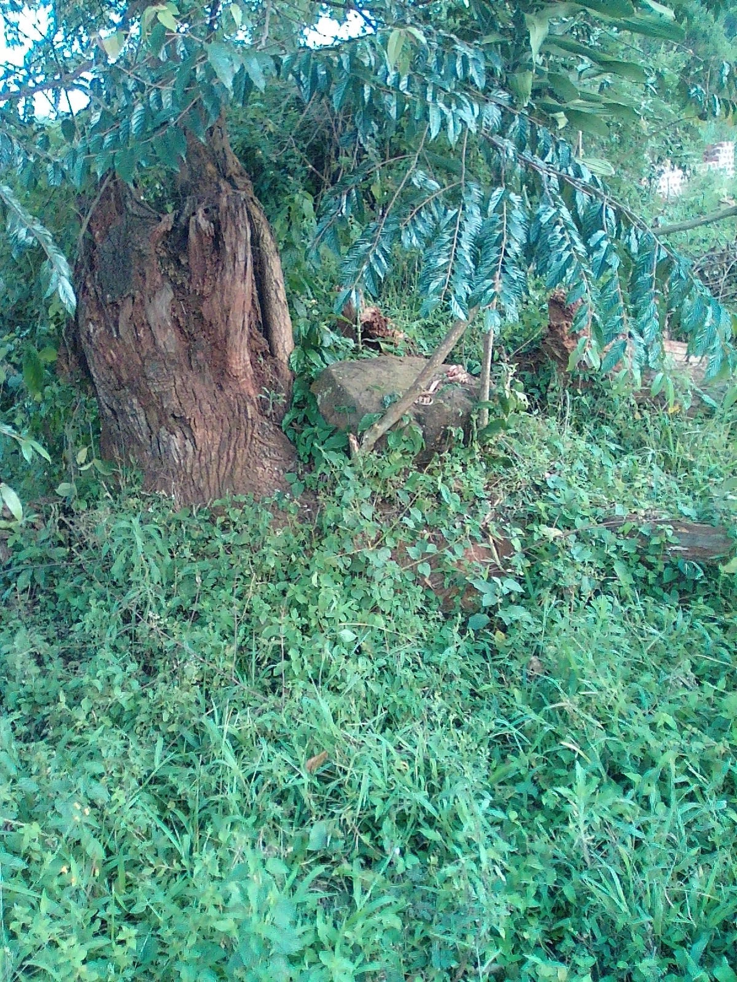
The Ssezibwa Miraculous Rock found in Lugasa LC1 – Ddungi Parish

- SOURCE OF SSEZIBWA AND MUBEYA RIVERS.
This is found in Bunyuma in Ddungi parish in Ngogwe sub county . the rivers are too historical that they have an origin in the Rock but later penetrates out at different points and gin join each at a particular point. After crossing the Mukono- kisoga – Jinja highway they separated and Mubeya turns in the east and pores onto lake vctoria while Sssezibwa turns West through Kayunga and pour its waters onto lake Kyoga.
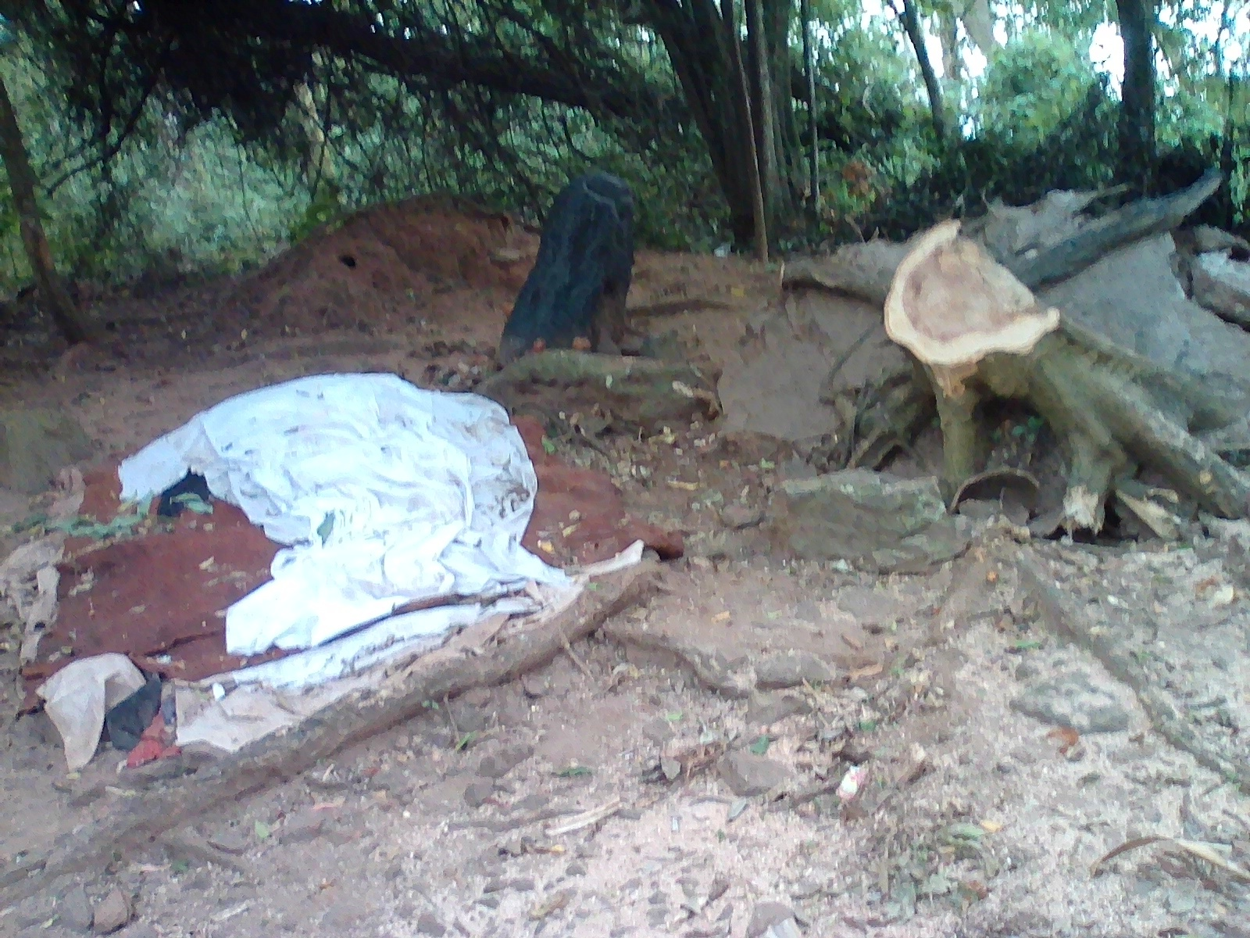
The black rock that forms the source of Ssezibwa&Mubeeya Rivers in Bunyumya LC1 – Ddungi Parish and below is where the two rivers first join their waters before they are separated again.
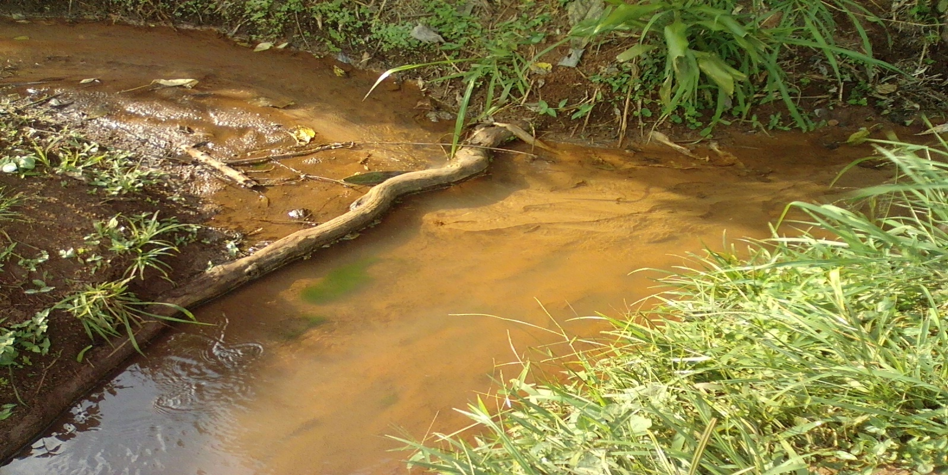
Ssezibwa and Mubeeya rivers point of interception

- KABAKA’S FARM in Bugembe LC1 – Lubongo Parish
The farm is historical in nature in that it is a demonstration farm with other cultural features that attract many people to visit and learn a lot.
- BASKERVILLE HILL in Baskerville LC1 – Lubongo Parish.
This is a hill where the former Anglican Missionary, Baskerville based to preach the Christian faith. There is a memorial church found at the peak of the hill that is so attractive to watch.
- BUWEWO VALLEY and MPEWO Clan cultural house in Kasi LC1 - Kiringo parish
The area has a very steep slope with a very miraculous stream that is so attractive. In the same village is where we find the cultural House for the Buganda’s Mpewo clan.
- KIZIRA ROCK in Kiwuluguma LC1 -
The rock is located in the water along kiwuluguma landing site, and it is alleged to have come moving and settled with the “Empeewo” clan Members.

- NKUSU CLAN HEAD in Ddungi LC1 – Ddungi Parish
The Buganda’s Nkusu Clan head Omutaka Sonja Peter Kayindi is found in the area with the Clan’s Shrine were all clan members assemble and discuss developmental issues. There is a clan house where all clan members gather for their various clan engagements. The Clan Shrine is also where Buganda’s Drum (Buganda Bumu) is kept that is drummed by Buganda’s Kabaka.

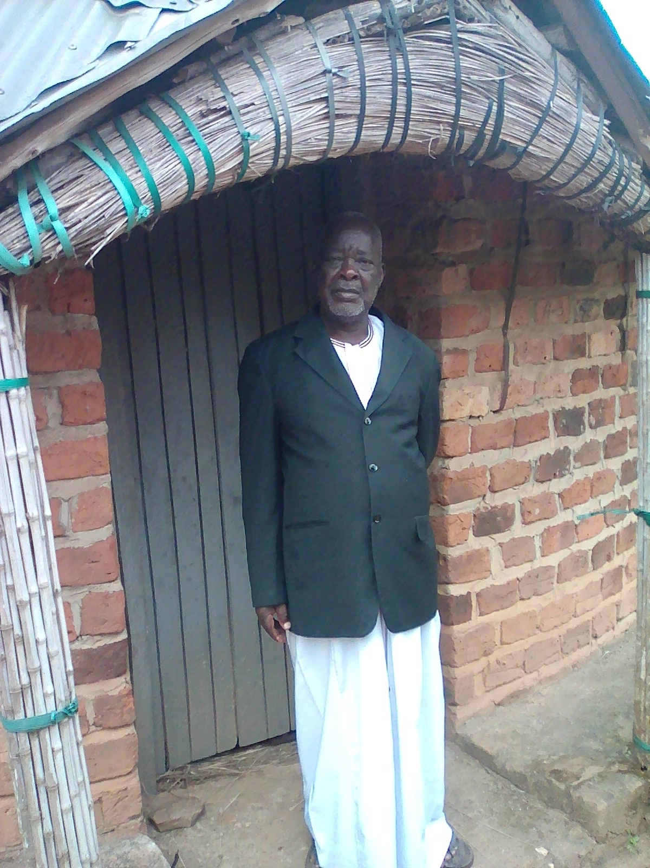
Buganda’s Nkusu Clan head Omutaka Sonja Peter Kayindi in front of the Clan’s Shrine and below is the clan house where all clan members gather for their various clan engagements
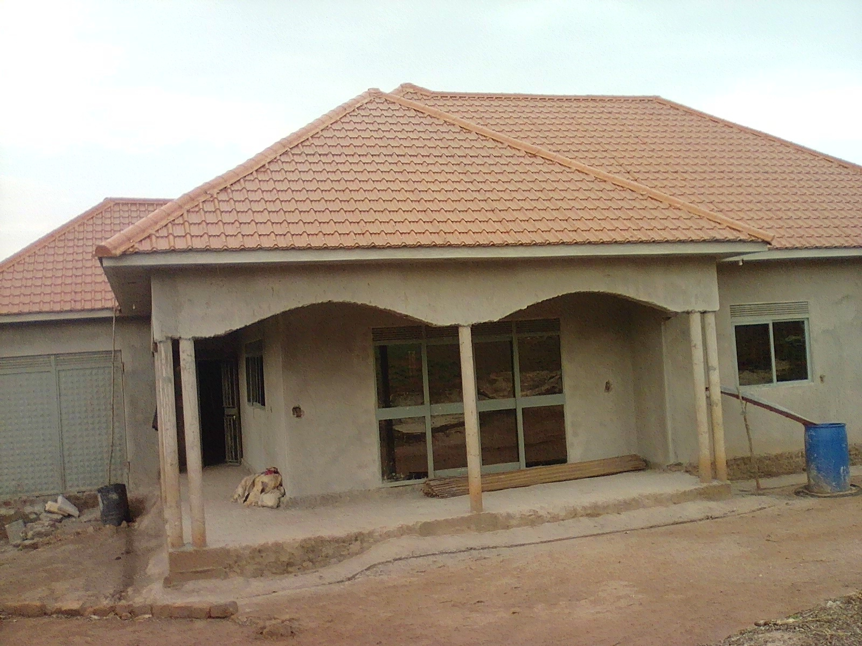

- KASAALA FALLS . The falls are found in Buwogle LC1 in Namulesa Parish in Ngogwe sub county and they are attractive with their eautifulscenaries
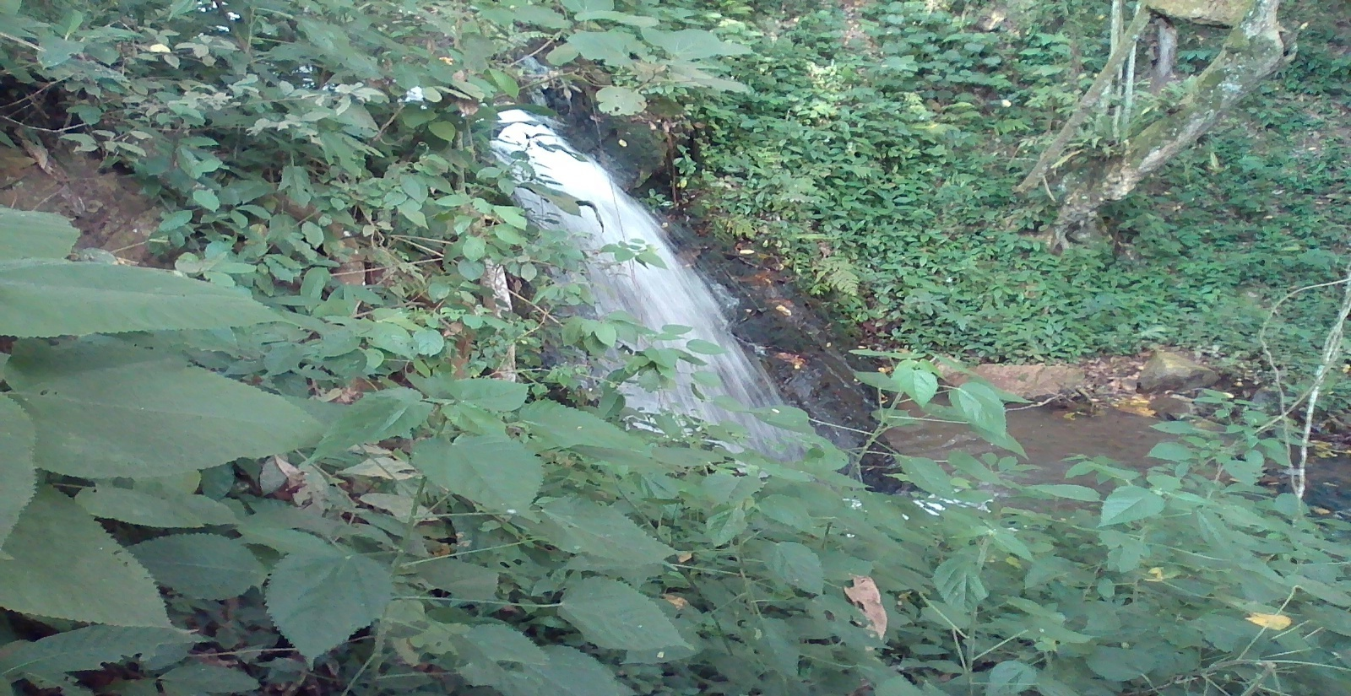
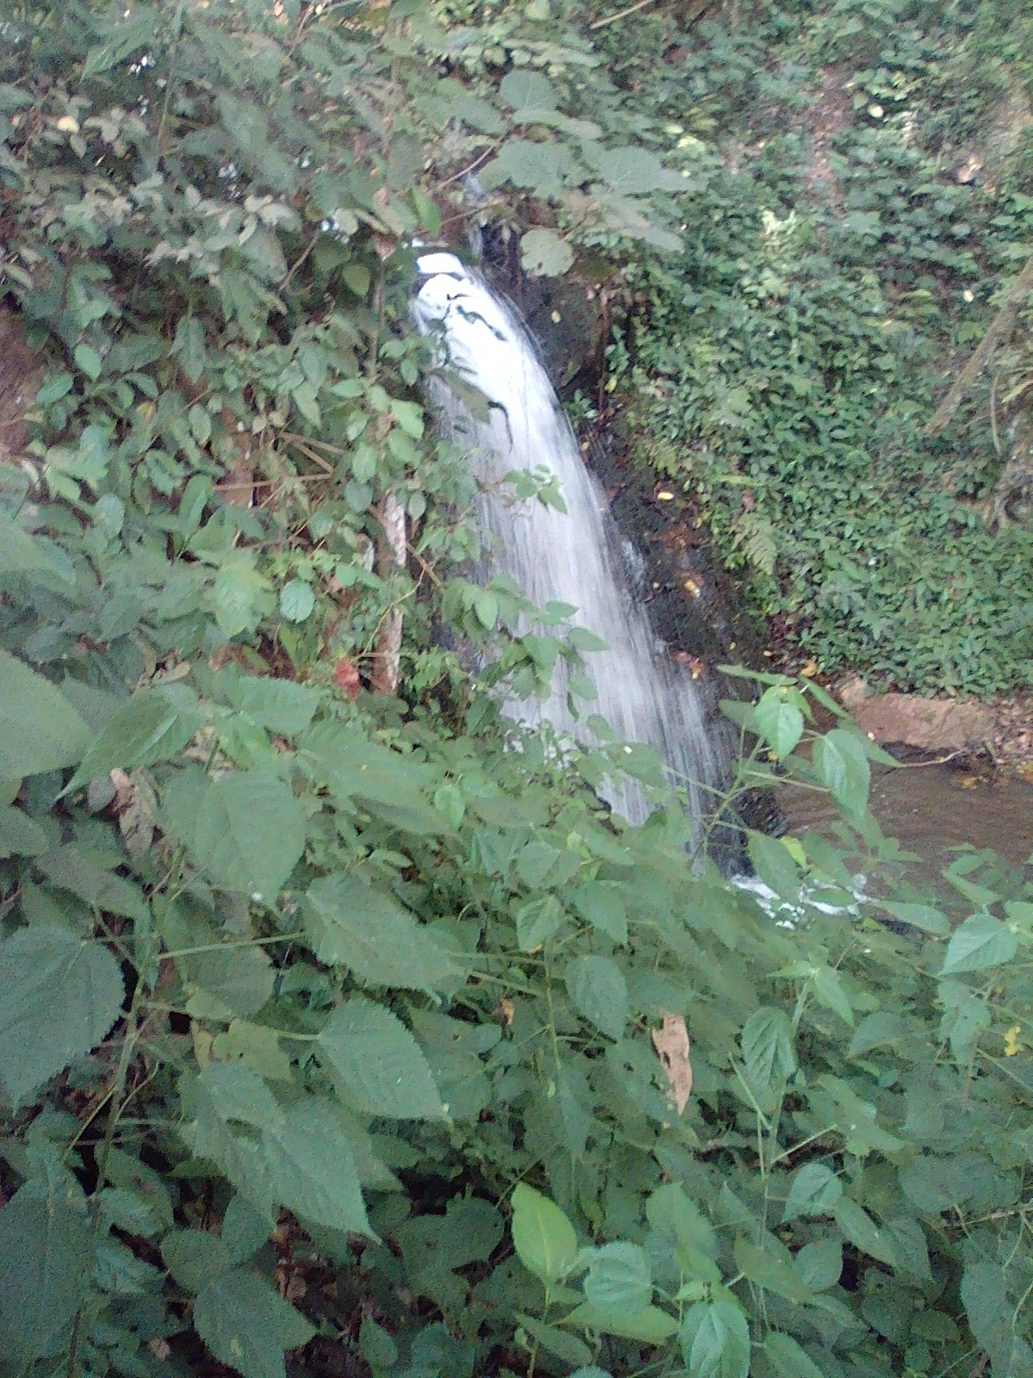

- Ssenyi landing site:
This is found in Ssi-Bukunja Sub County and its one of the biggest landing sites in the district second to Kiyindi. The sites contribute huge revenue through numerous activities such as fishing. Its good scenery accompanied with the cute panorama view attracts so many people.
However the landing site is being affected by the rising water levels on Lake Victoria which have even tried to cut off the road, leading to the landing site thus hindering all the activities in this area. And also the rapid growing water weed is yet another challenge to the fishermen.
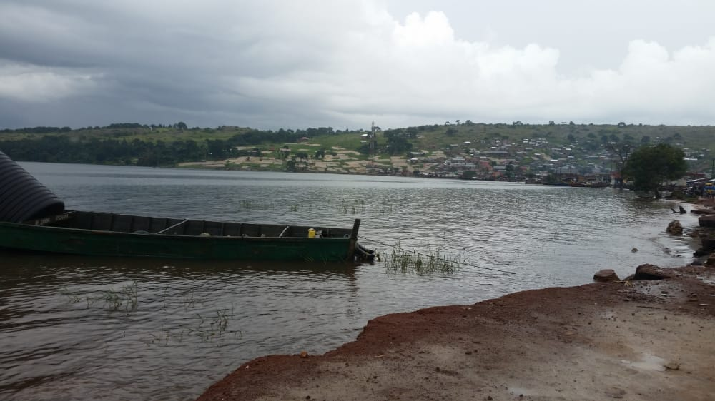
The water levels just adjust to the main road connecting to the busines area at the landing site
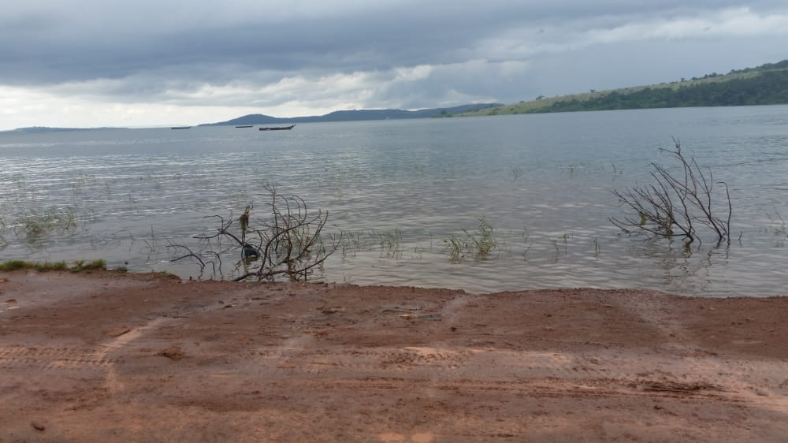

- MUSANA CAMP: is found in Ssi-Bukunja Sub County in Gaba adjacent to Nalumuli landing site. It was established in 2008 as a Christian children camp merging from the Children Ministry of New Hope Uganda based in KasanaLuweroNakaserke District. It’s a cool place for camping as wel as a good hospitable management. It has accommodation facilities, Musana Beach, waterfalls and mountain climbing.
However Musana camp faces a problem of encroachers, the beach itself has also suffocated the rising water levels and also the water weed and also the poor road from Nangunga up to Ggaba is yet another challenge. FOR BOOKINGS AND INQUIRIES bookings@musanacamp.org or 0759220943

The volley ball ground at the musana camp being affected by bth the water weed and the risng water levels
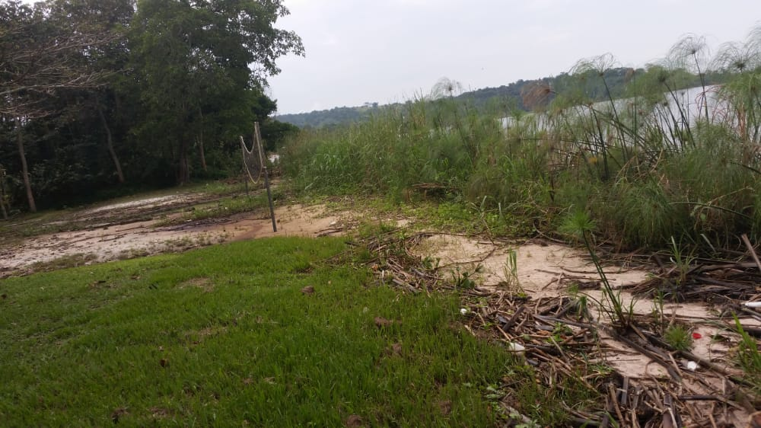
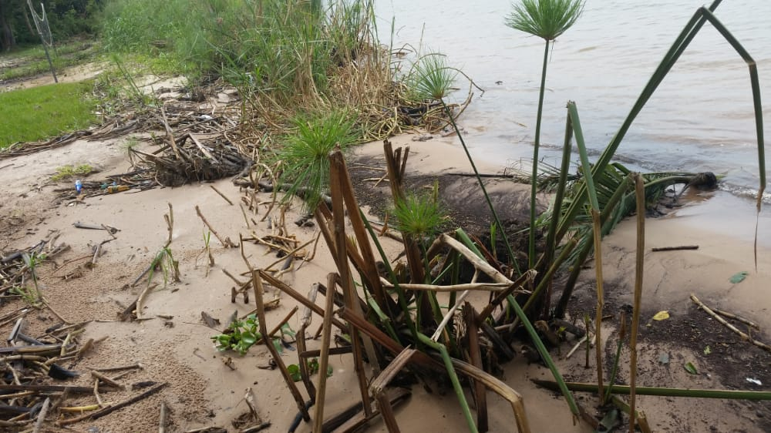
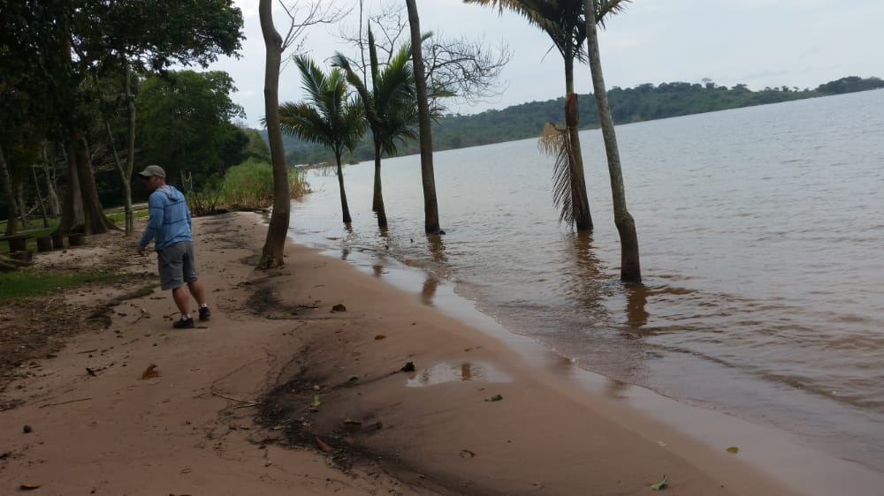
Musana beach affected by the rising water levels as the area supervisor Mr. SEED narrates.

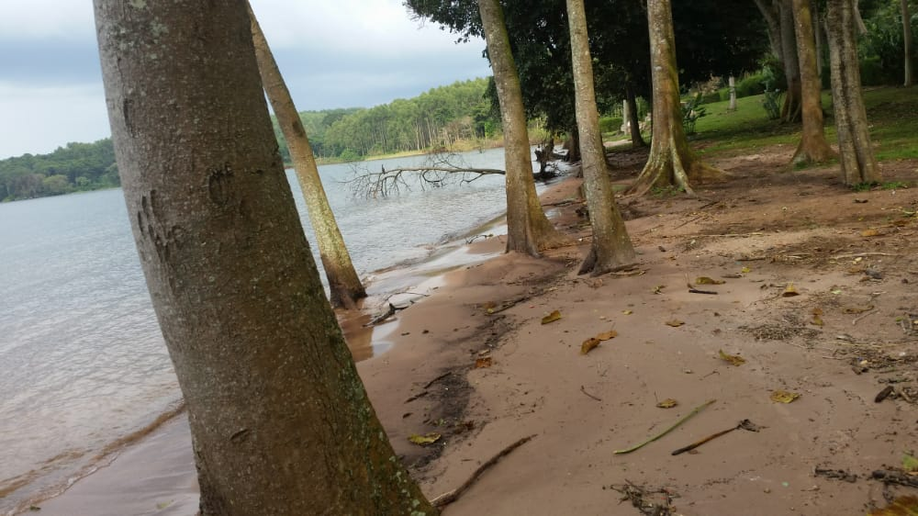

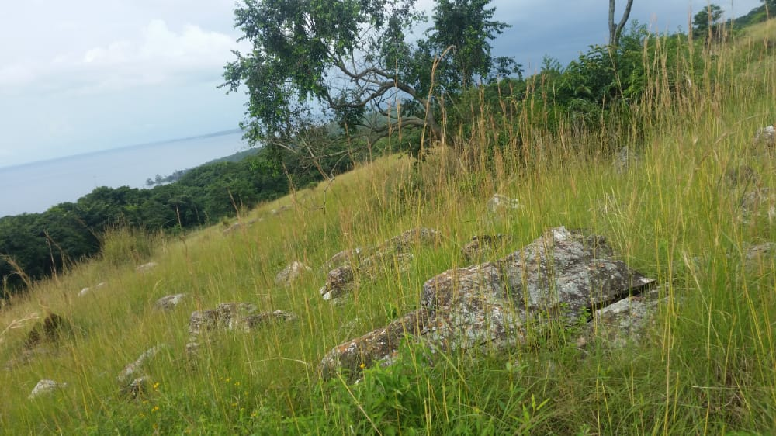

- Kiyindi landing site:
This is found in Kiyindi town council and it’s the major landing site in the district. This landing has the path to Buvuma district as the ferry is being hacked here. Kiyindi is a busy centre and when u take its panorama view it has rocks with good scenery , the birds at the waters , the water waves also poses a cool atmosphere at the landing site.

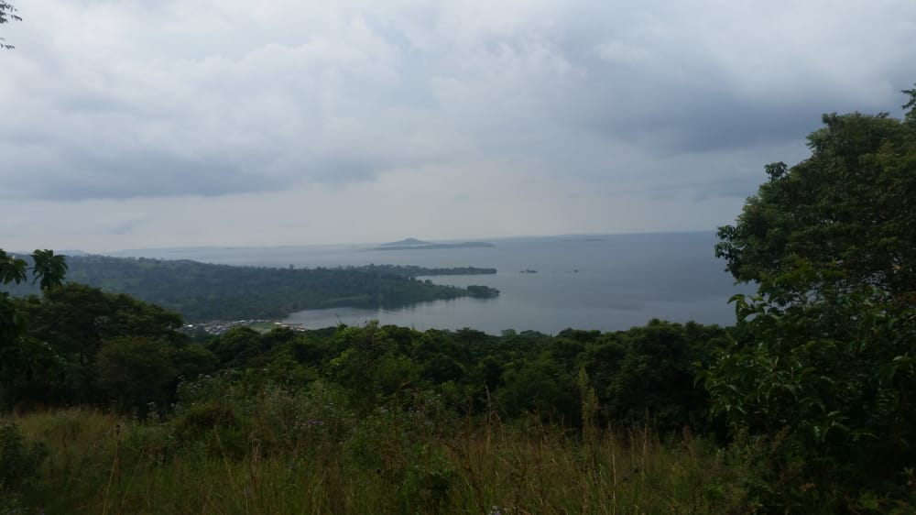

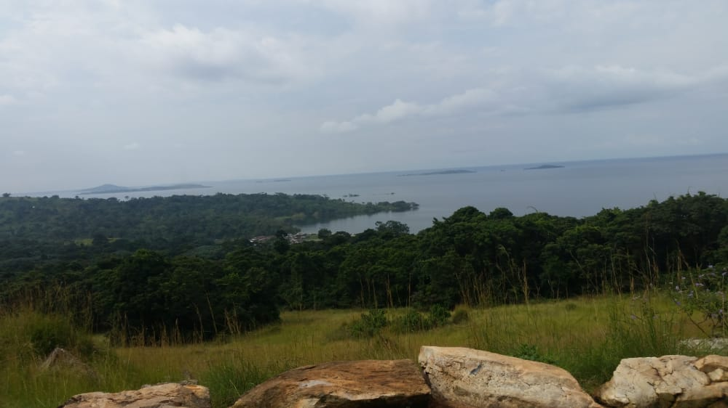

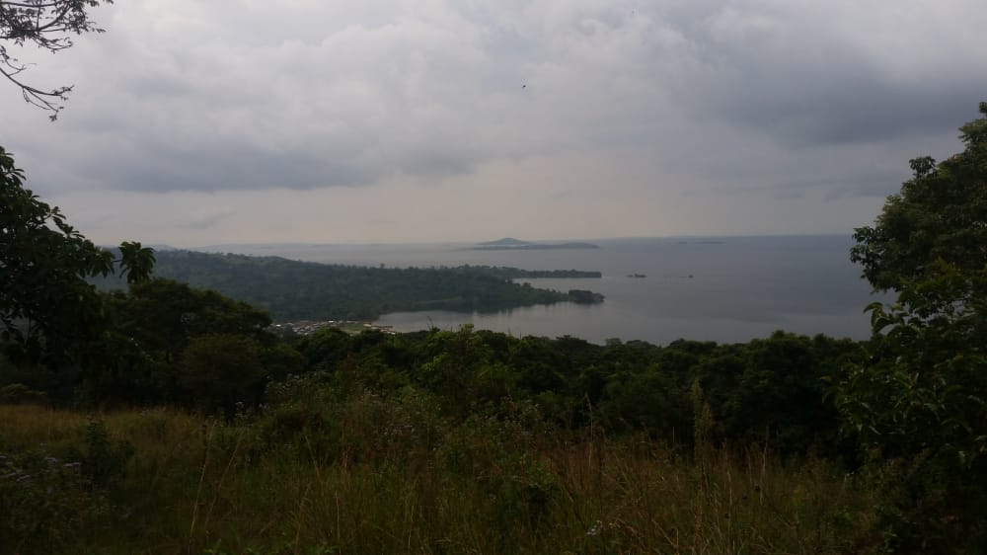

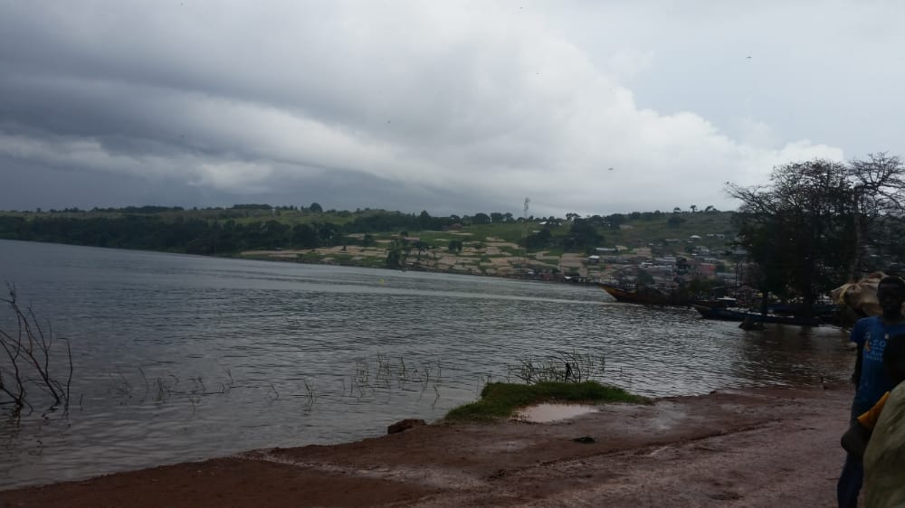

Mirembekasubi:
This place is found in Buikwe Sub County in Kitazi parish and it’s called Mirembe. It is said that SSEKABAKA MUTEESA 1 used to stay in this area and later shifted to Kampala where he even namedkasubiNabulagala reciting the name from kasubiMirembe where he was living. This place is historical in Buganda culture in that it’s where the middle pole which was used in the Royal tombs of kasubi wasgot.

ACCOMODATION FACILITIES
 | NAME OF ACCOMADATION FACILITY | CONTACT | REMARKS
 | KIYINDI TOWN COUNCIL
 | KYATEREKERA GUEST HOUSE
 | MUWUMUZZA GUEST HOUSE
 | BASIIMA GUEST HOUSE
 | MEET YOU BAR AND LODGE
 | ROX GUEST HOUSE
 | KIMOTE BAR
 | ANI YALI AMANYI GUEST HOUSE
 | COOL BREEZE GUEST HOUSE
 | NAJJA SUBCOUNTY
 | AMBIANCE BAR
 | AKWATA EMPOLA
 | MARIANA CLUB |  | Self contained rooms
 | APLE GUEST HOUSE
 | KINFUMISE LODGE
 | KYARENGA
 | BOGEDDE GUEST HOUSE
 | JOFOS GUEST HOUSE
 | APEX GUEST HOUSE
 | CUBANA BAR AND LODGE |  | Poor
 | SILENT CORNER |  | Moderate
 | JOKO’S BAR AND LODGE
 | BUIKWE TOWN COUNCIL
 | KK GUEST HOUSE | 0756676880
 | HUNTERS GUEST HOUSE | 0772489967/  0772453632
 | KINGUDDE LODGE | 0754511902
 | SINA BAR AND GUEST HOUSE | 0754511902
 | KASIBANTE BAR | 0702251868
 | DILLEMA
 | MUTEBI GUSEST HOUSE

GUEST HOUSES IN BUKWE TOWN COUNCIL
N/S | NAME OF GUEST HOUSE | CONTACT | OWNER | VILLAGE

